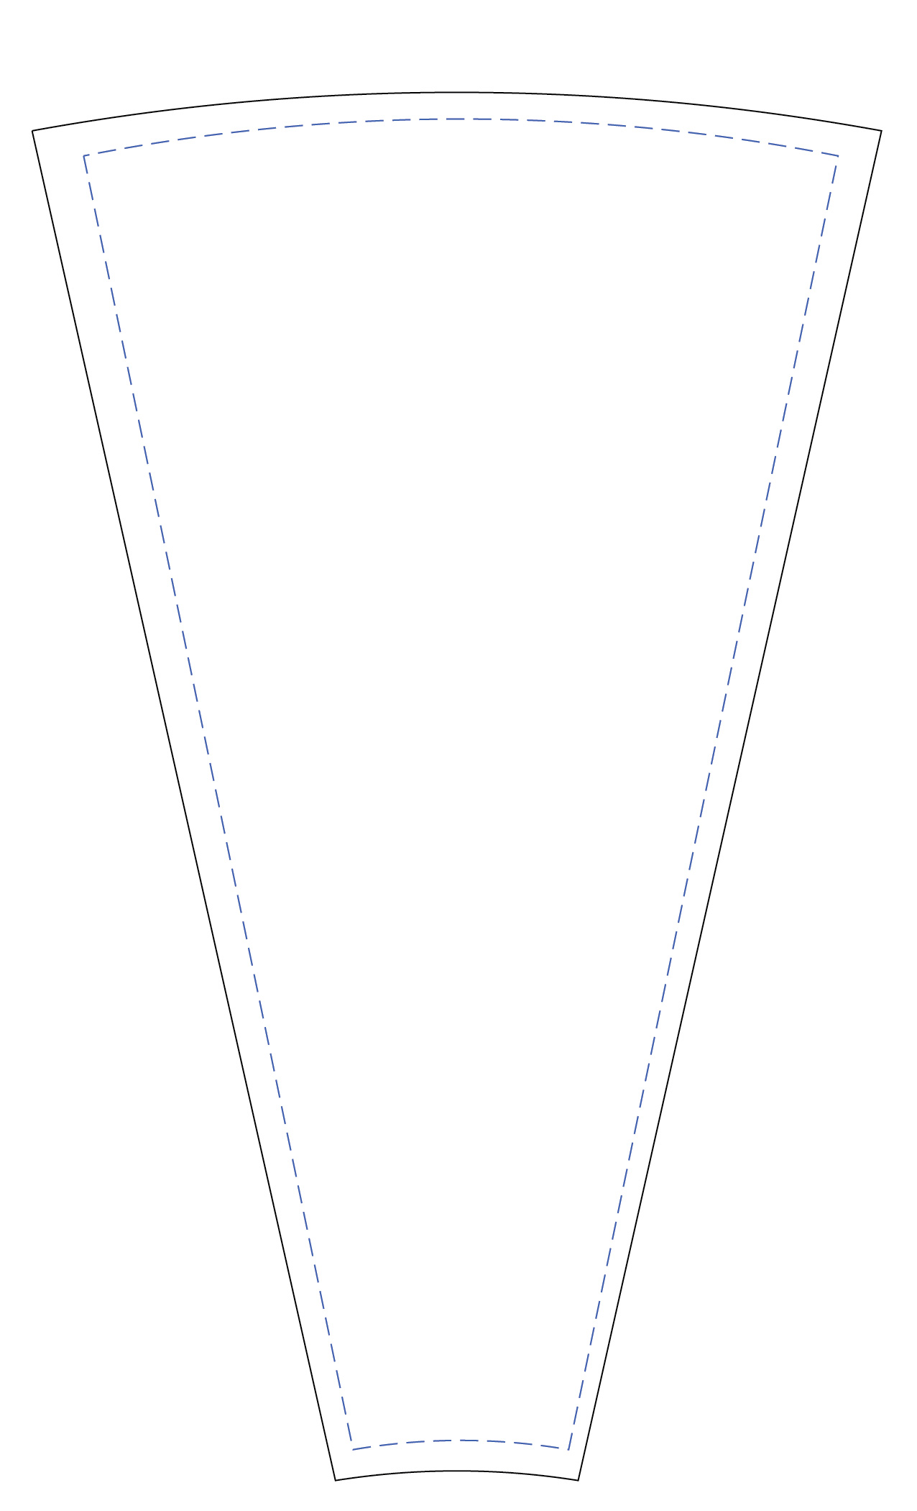

Big Wheel Prize Insert

1. Customize the insert by right-clicking it and choosing “format picture”
2. Delete line if not needed.
3. Print on 8.5 x 11 paper @ 100% - do not “scale to fit”
4. Cut on inside line.

Big Wheel

Full Insert

1. Customize the insert
2. Print on legal paper
3. Cut on dotted line.
4. Have FUN!!!