Micro Prize Wheel Insert Template

- Customize the insert by right-clicking it and choosing “format picture”.
- Print on 8.5 x 11 paper @ 100% - do not “scale to fit”.
- Cut on inside line.

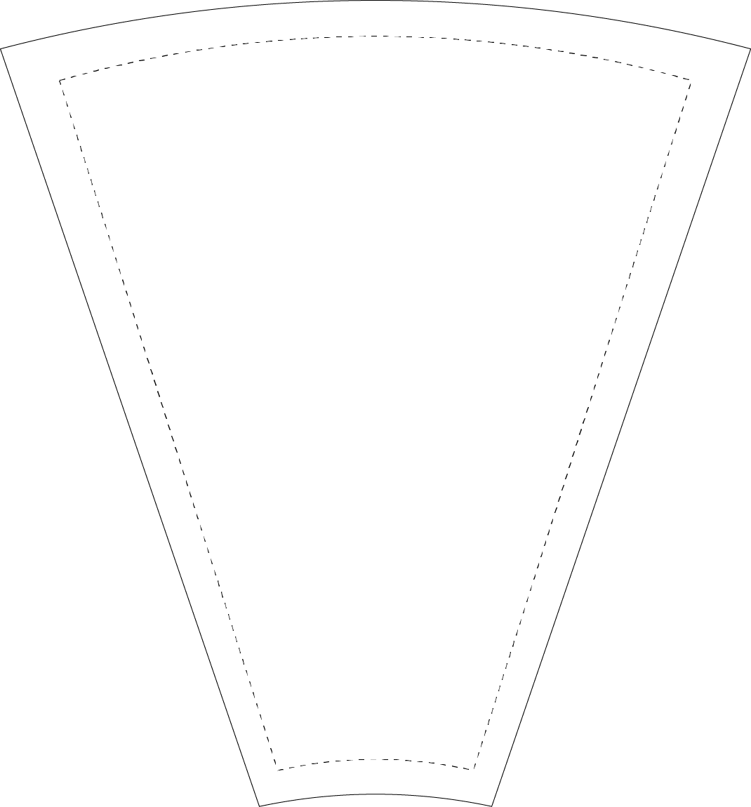
TEXT

